 | JSPM’s RAJARSHI SHAHU COLLEGE OF ENGINEERING  (An Autonomous Institute, Affiliated to Savitribai Phule Pune university)  Department of Electronics & Telecommunication Engineering  One Page Project Summary (A.Y 2026-27) | 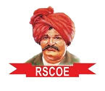

PROJECT TITLE: Multimodal AI Teaching Copilot for Real-Time Visual Learning Generation
CATEGORY OF THE PROJECT: Design and Development of Software

PROJECT DOMAIN: Artificial Intelligence in Education (speech recognition, large language models, real-time visual systems)
GROUP NO: 03
Group Member 1: Paritosh Vinayak Raut (RBT23ET125)
Group Member 2: Prachi Vijay Potdar (RBT23ET122)
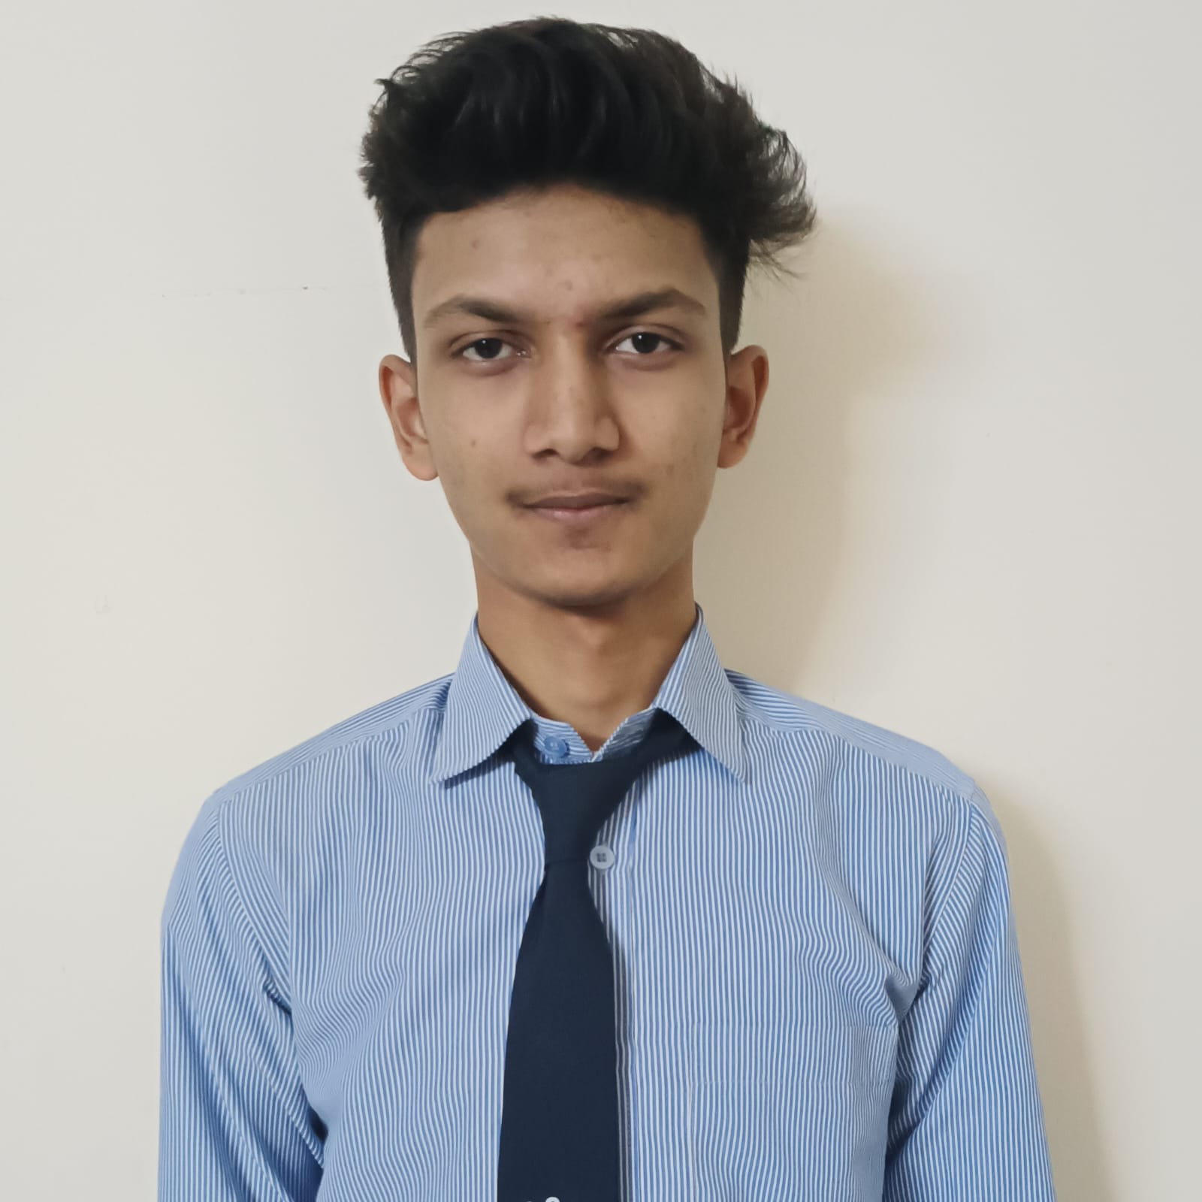  Name: Paritosh Vinayak Raut  PRN: RBT23ET125  Mail ID: paritosh21raut@gmail.com  Mobile: 8177927942 | 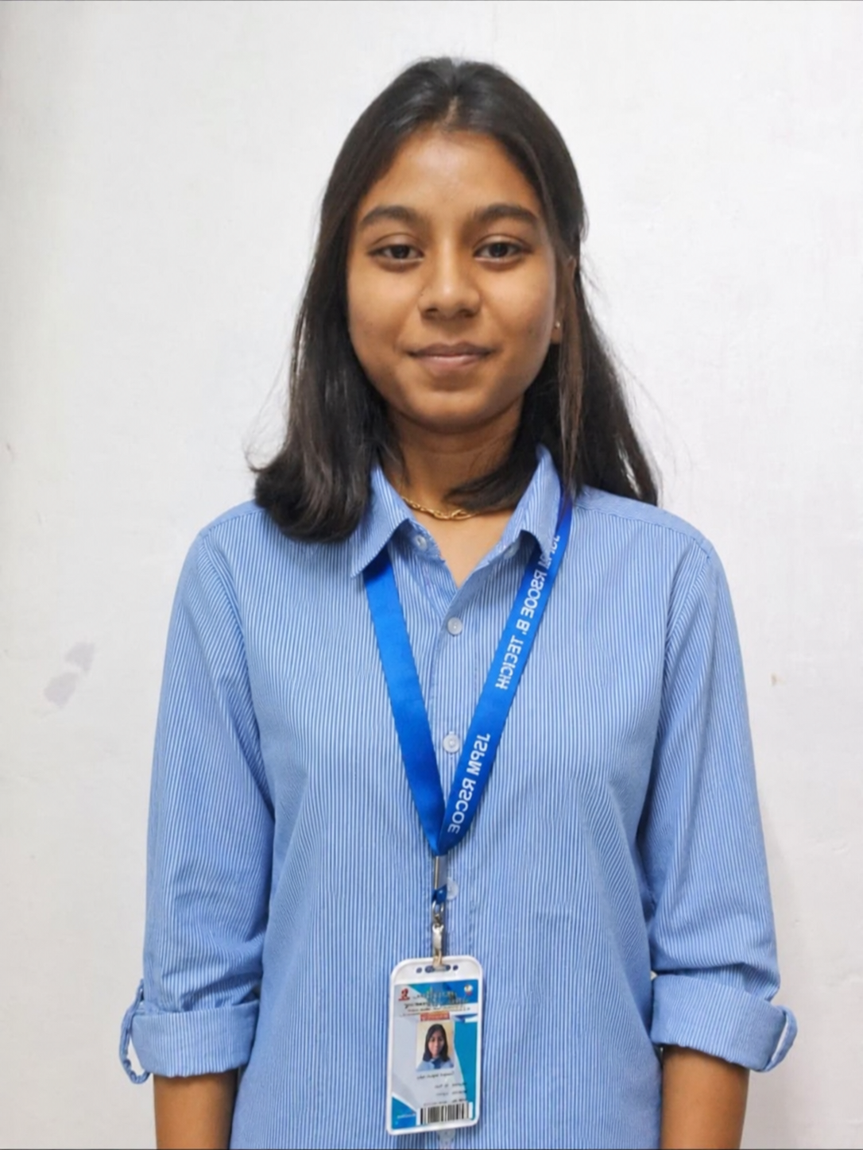  Name: Prachi Vijay Potdar  PRN: RBT23ET122  Mail ID: prachipotdar50@gmail.com  Mobile: 8624023078

ABSTRACT:
Prepared slides cannot show the examples and explanations a teacher adds while teaching, and an LLM that regenerates slides from a growing transcript keeps rewriting what students are reading. This project builds a teaching copilot that listens to the teacher and, during the lecture, puts a structured, continuity-aware slide deck on the classroom projector: typed layouts, typeset formulas, checked images and live concept simulations. Speech is transcribed locally; a large language model only interprets bounded units of speech, while a deterministic planner decides the slides and only extends the deck. The system runs on one laptop with a 4 GB GPU and free AI services.

PROBLEM STATEMENT:
To design a low-cost system that converts a teacher's live speech into a structured, stable and transcript-faithful visual lesson (slides, formulas, images and parametric simulations) on the classroom projector during the lecture, while keeping the teacher in control.
OBJECTIVES:
• Capture and transcribe classroom speech locally in real time (Silero VAD, faster-whisper on GPU).
• Track the topic online and interpret bounded speech units with an LLM that returns only validated labels.
• Plan slides deterministically so the deck only grows; guard content against the transcript.
• Show slides, formulas, images and spoken-value-driven simulations on projector, teacher and student views.
• Evaluate latency, accuracy, stability and teacher ratings on held-out lectures and against an LLM baseline.
IMPLEMENTATION:
Python (asyncio) core with typed events and an SQLite event log; faster-whisper (Whisper medium.en, int8) and Silero VAD for speech; MiniLM embeddings for topic tracking; a rule-based gate and bounded prompts (< 3,000 tokens) to the Groq free tier (gpt-oss-120b, Qwen3) with Pydantic validation and a deterministic fallback; extend-only planner, coverage and formula guards; composer with 10+ layouts, KaTeX and CLIP-checked open-licence images; FastAPI + WebSocket views /display, /control and /view; 21 simulation templates (mechanics, circuits, RLC, p-n junction, TCP, routing, optics, gas laws, biological processes) with Python solvers; post-lecture notes, assignments, quizzes and PPTX.
RESULTS:
• 36 held-out lectures (409 min, 6 speakers + MIT OCW / NPTEL): median speech-to-slide delay 11.2 s.
• 18 annotated lectures: topic-boundary precision 0.78, 86.6 % of key facts on a slide, only 0.9 % statements not said; five teachers rated the slides 3.87–4.17 / 5.
• Versus an LLM-controlled baseline: seen statements rewritten 2.0 % vs 38.2 %, lower in all 18 lectures (p < 0.001).
• Simulations: show precision and recall 1.00 on 66 lectures, no false simulation; solver values match hand-computed textbook values; 0 LLM tokens.
• Tests: 1,547 unit tests and 122 real-browser tests passing.
SPONSORSHIP:
Nil (self-funded; only free and open-source tools used).
PROJECT COMPETITION: —
PUBLICATION:
IEEE conference paper “Multimodal AI Teaching Copilot: Live Slide Generation from Lecture Speech” (P. Potdar, P. Raut, D. Magdum, S. Kale, S. Patnaik), 6 pages. Conference / status: __________
SPECIAL ACHIEVEMENT IF ANY: —

Mrs. Deepali Magdum | Mrs. D. K. Magdum, Mrs. S. P. Pattanaik | Dr. S. C. Wagaj
Project Guide | Project Coordinators | HOD

